# 5G TECHNOLOGY

# INTRODUCTION:

It is used for communication. first of all we have to know how communications takes place in mobile phones, Computer.

In olden days the people shared their information by sending a letter from one place to another by using post.it is used for long distance communication. But it takes lots of time to receive. Long distance communication can be take place in different types. One of the most common method in the olden days to send a urgent message is by burning a fire .by burning it has produce a light.by seeing that light the peoples understand the message. This is seen by human eyes.it is also called as electromagnetic radition. After technology growth this seen radiation is converted to unseen radiation by using this long distance communication is created.in olden days the radios are created by this unseen radiation. from the past days to this present days we are using this electromagnetic radiation. Especially in mobile phones, radios ,peripheral and other communication devices. this electromagnetic radiation incarnation in many types. this is called as generation.

# What is electromagnetic radiation?

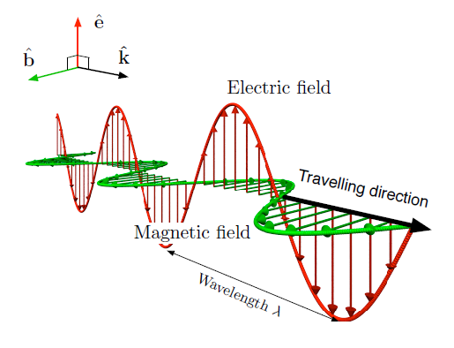

It is made up of waves and the electromagnetic field that spread through space, and will carry radiant energy.

It includes

-radio waves

-microwaves

-infrared light

-uv rays

-x rays

-gamma rays

-it can be derived by both manmade and natural

Example for electromagnetic radiation:

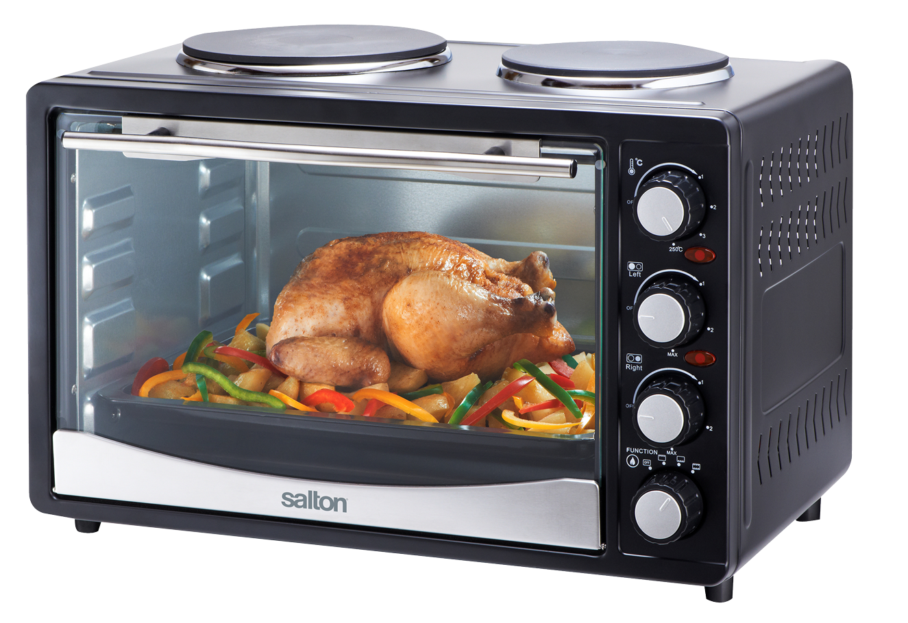

Example for electromagnetic radiation in our daily life is our daily foods heated in a oven, heaters, television, radios etc .

## List of technologies

1G,2G,3G,4G,5G

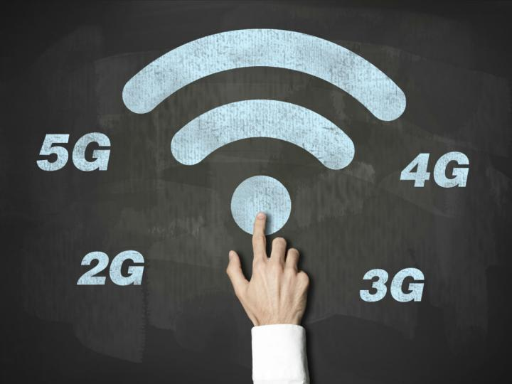

# What is 1G?

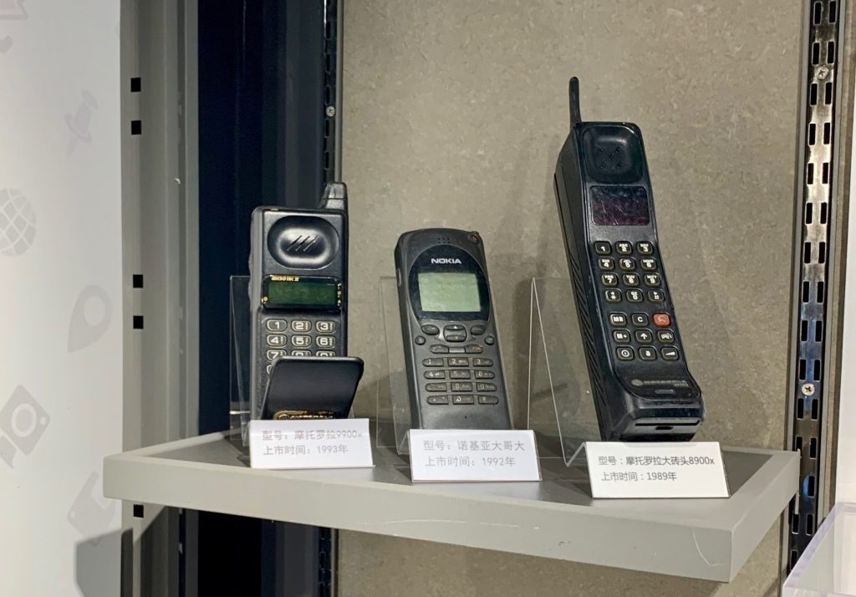

In the periods of mobile phone discovered the electromagnetic radiation used is called 1G.1G means first generation.it is a wireless communication used for long distance.1G is in the period of 1980s.it is created by nippon telegraph and telephone in Japan.speed of 1G is 2.4 kilobytes per seconds.we can do only voice call. Battery used is poor.low security.it is a analog communication.

# What is 2G?

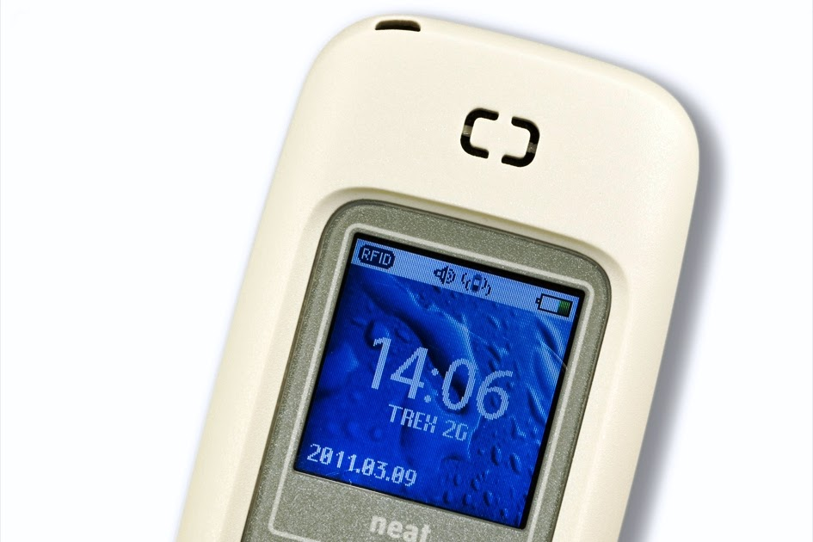

Its is a second generation communication used for long distance communication.as in 1G we can only use voice calls but in 2G we can send a text message, picture message.as 1G is in analog but in 2g we uses digital in first time.In the year 1991.its data speed is upto 64 kbps.it is more quality than first generation. Example for 2g is gsm,gprs,edge. It can be used in several countries still now.

# What is 3G?

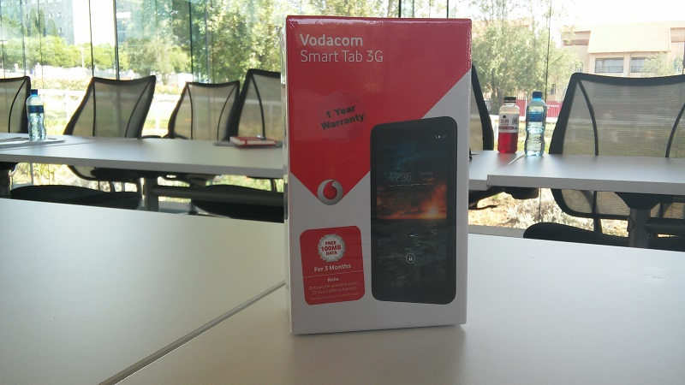

It is a third generation used for long distance communication.it is a upgraded version.it is accessed over internet.it also support video calls.it is in 2001.example for 3g is iphones,it is very expansive than 2g.

# What is 4G?

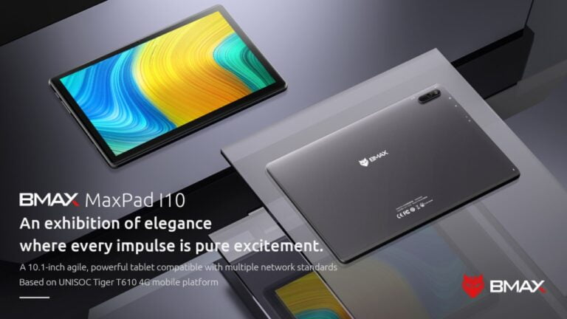

Keeping at the trend of a new mobile generation every decade,it was introduced in 2011.it is much quality than 3g.we can access mobile web high definition mobile. the basic term is MAGIC. M stands for mobile multimedia,A stands for anytime anywhere and g stands for global mobility support I stands for integrated wireless solution.and C stands for customized personal services

### What is 5G?

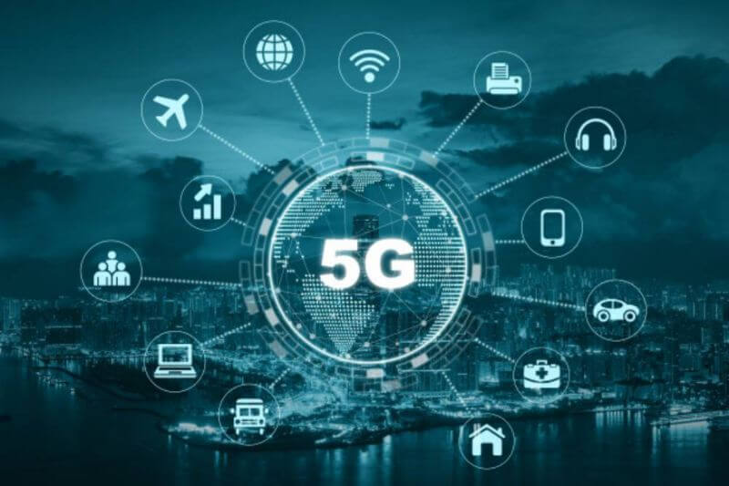

It is started from late 2010.it is a complete wireless communication with almost no limitations.it is highly supportable to WWWW .wwww stands for wireless world wide web.it is goin to give tough competitions to computes and laptops.it is very expansive.there is public and private 5g networksit includes low latency,fast speed.

what is public netwoks in 5g?

it is a standard features of 5G.when we choose to operate any business with public networks,we must understand that the network lack control over network settings.

#### What is private networks in 5G?

It has both dependent and independent networks.we must choose independent .it will come under cost, speed and other advantages.

##### About 5Gs:

As 5g uses electromagnetic radiation.this is made up of photons of energy particles.it travels in light.the shape of the waves shows that the electromagnetic radiation is of seen or unseen radio waves.it can be catagorized into two parameter.the one parameter is wavelength.

##### What is wavelength?

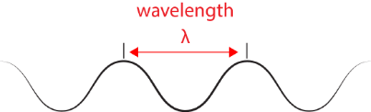

Distance of the continuous two waves is called wavelength.

Another parameter is frequency

##### What is frequency?

it is number of occurences of waves in per second.

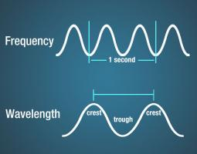

It is measured in hertz.

1 hertz means the number of waves discovered per second .as in 2g generation we have transferred the data in digitial ones.as 0s and 1s.

##### Example for digital modulation:

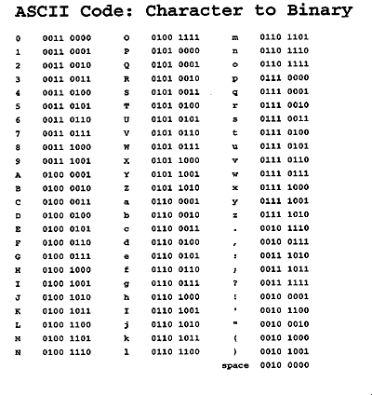

[This Photo](https://www.elon.edu/e-web/imagining/about/kidzone/codebreakers.xhtml) by Unknown Author is licensed under [CC BY](https://creativecommons.org/licenses/by/3.0/)

When we want to send a letter-A as a message to other cellphone ,we have to type as A,cellphone changes A to a binary data(0 and 1) binary code for A is 010000001 from this binary values the waves are formed .as 0 as a one type of wave and 1 has a another type of wave.the waves thus formed is called as electromagnetic radiations.these radiations travels to a tower which is nearby to our phone is occurred the tower gained that waves,and identifyto which phone we want to send this message and identify a nearby tower to that phone where we want to sent and send the waves to that tower.and that waves is transferred to that phone through tower. that cellphones changes receive a binary code .in our cellphone we have a processor that coverts that binary code to a message as alphabets.

If I have send this letter A in 1 hertz frequency we have 8 bit code so there forms 8 waves as 1 wave transforms through 1 waves then 8 bit occurs 8 hertzif we have transfer in 8 hertz then in 1 second we can send a message as A.as frequency increases then the data of the wave is also increased.as we discuss earlier about the generation of technologies,it uses this electromagnetic radiation.but the frequency increases in generation by one generation.as the frequency increases then the data in one second also increases.so that in 4g we have no tower we can send a quick message but in 3g it is not earlier than 4g.in this way the generation are created.

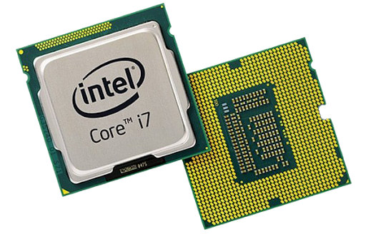

##### Electromagnetic radiations uses how many types of frequency?

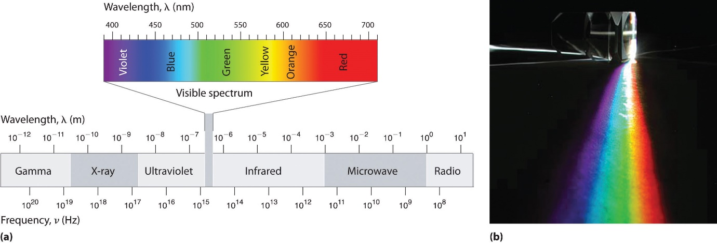

To know this we have to know the diagram of electromagnetic spectrum.from the diagram we know that the left side of the spectrum can be seen and the right side of the spectrum can be unseen.the frequency ranges is 540-1600 khz.fm radio has 88-108 mhz frequency.5g uses 600-28 ghz frequency.

##### Disadvantage:

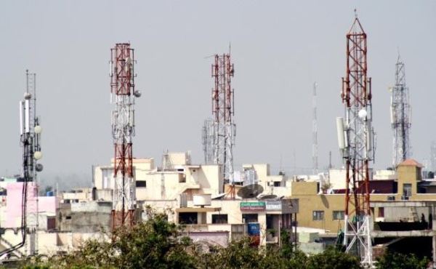

-as frequency increases the strength of waves also increases and the distance also readuces

-5g signals cannot travel in a long distance so that tower also should be nearby so we have construct more towers in nearby

##### Advantage:

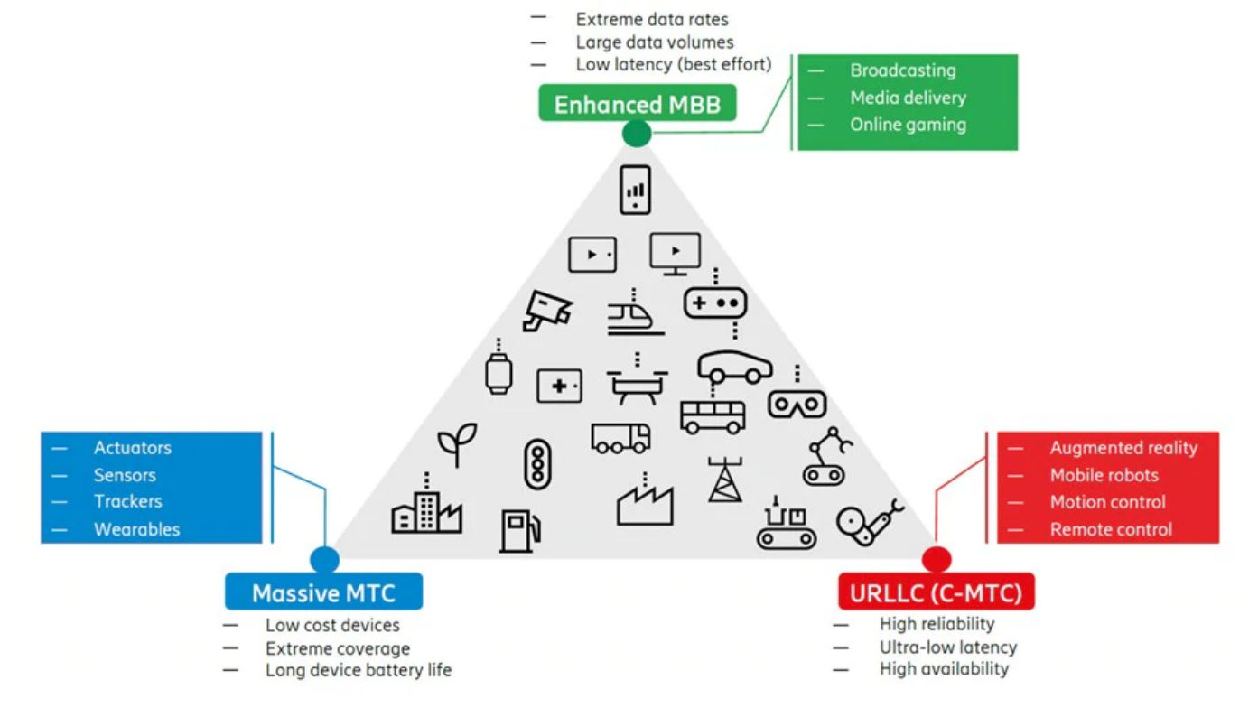

-5g speeds are expected to be up of 100 times faster

-it has greater speed

# Is our country having 5g?

There is a delay in the 5g network in india.the government has announced that would take place in 2022.so we are waiting for 5g technology.

## Applications:

Smart cities and homes

IOT

Autonomous driving

Mobile phones

### Countries using 5gs

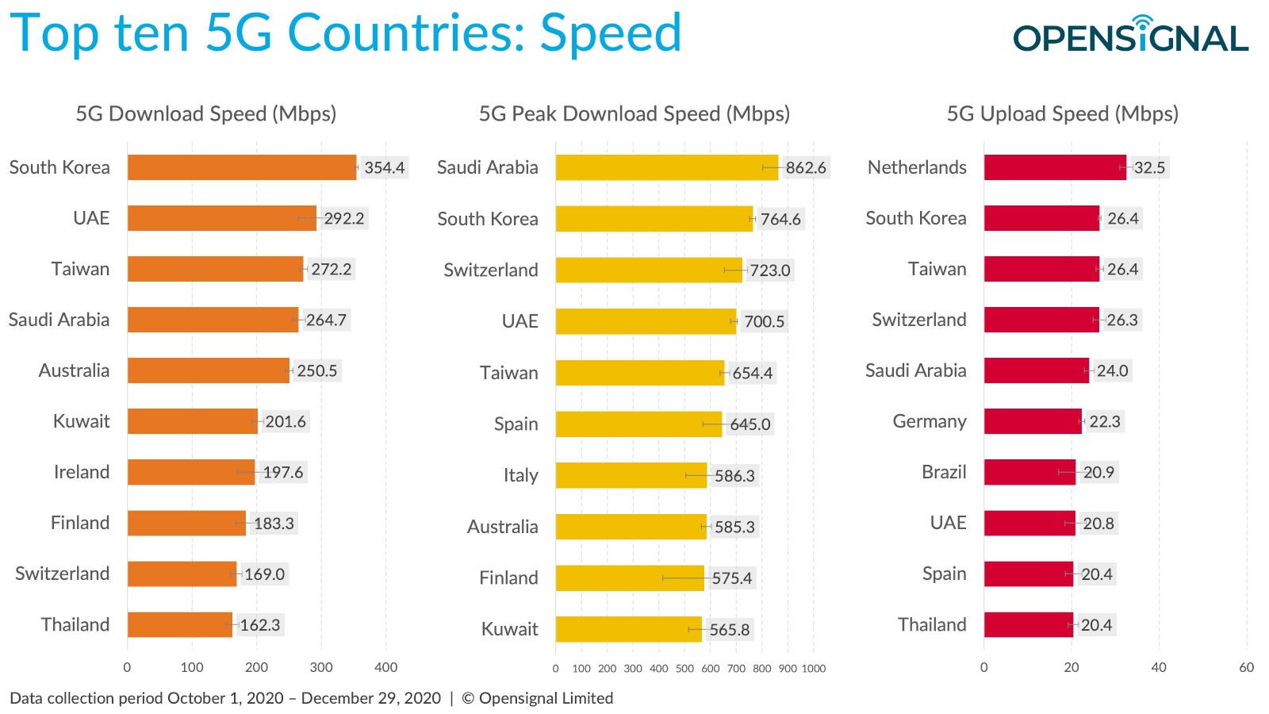

China

Philippines

South korea

US etc…

“HOW CAN YOU KNOW YOU ARE TRIALING 5G…..WHEN YOU DON’T KNOW WHAT IT IS!....”